**Aim:** To make the clear division for making the decisions about the classes using Decision Tree

**IDE:** R Studio

**Theory:**

Suppose a bank has to approve a small loan amount for a customer and the bank needs to make a decision quickly. The bank checks the person’s credit history and their financial condition and finds that they haven’t re-paid the older loan yet. Hence, the bank rejects the application.

But here’s the catch – the loan amount was very small for the bank’s immense coffers and they could have easily approved it in a very low-risk move. Therefore, the bank lost the chance of making some money. Now, another loan application comes in a few days down the line but this time the bank comes up with a different strategy – multiple decision-making processes. Sometimes it checks for credit history first, and sometimes it checks for customer’s financial condition and loan amount first. Then, the bank combines results from these multiple decision-making processes and decides to give the loan to the customer.

Even if this process took more time than the previous one, the bank profited using this method. This is a classic example where collective decision making outperformed a single decision-making process. A decision tree is a supervised machine learning algorithm that can be used for both classification and regression problems. A decision tree is simply a series of sequential decisions made to reach a specific result. Here’s an illustration of a decision tree in action (using the above example):

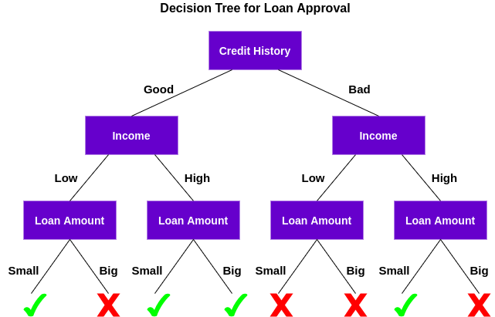

First, it checks if the customer has a good credit history. Based on that, it classifies the customer into two groups, i.e., customers with good credit history and customers with bad credit history. Then, it checks the income of the customer and again classifies him/her into two groups. Finally, it checks the loan amount requested by the customer. Based on the outcomes from checking these three features, the decision tree decides if the customer’s loan should be approved or not.

The features/attributes and conditions can change based on the data and complexity of the problem but the overall idea remains the same. So, a decision tree makes a series of decisions based on a set of features/attributes present in the data, which in this case were credit history, income, and loan amount.

**Program:**

Write a R script to perform classification using Decision Tree approach

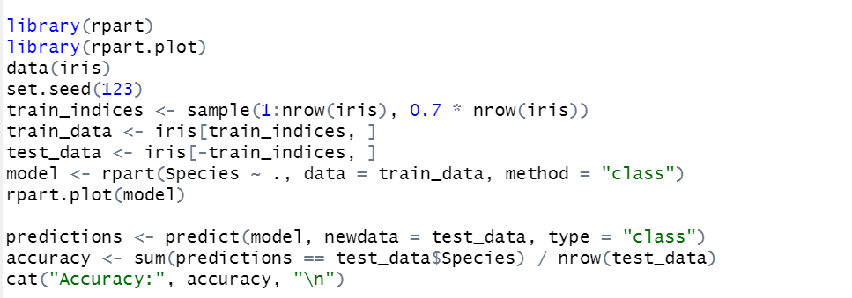

**Output:**

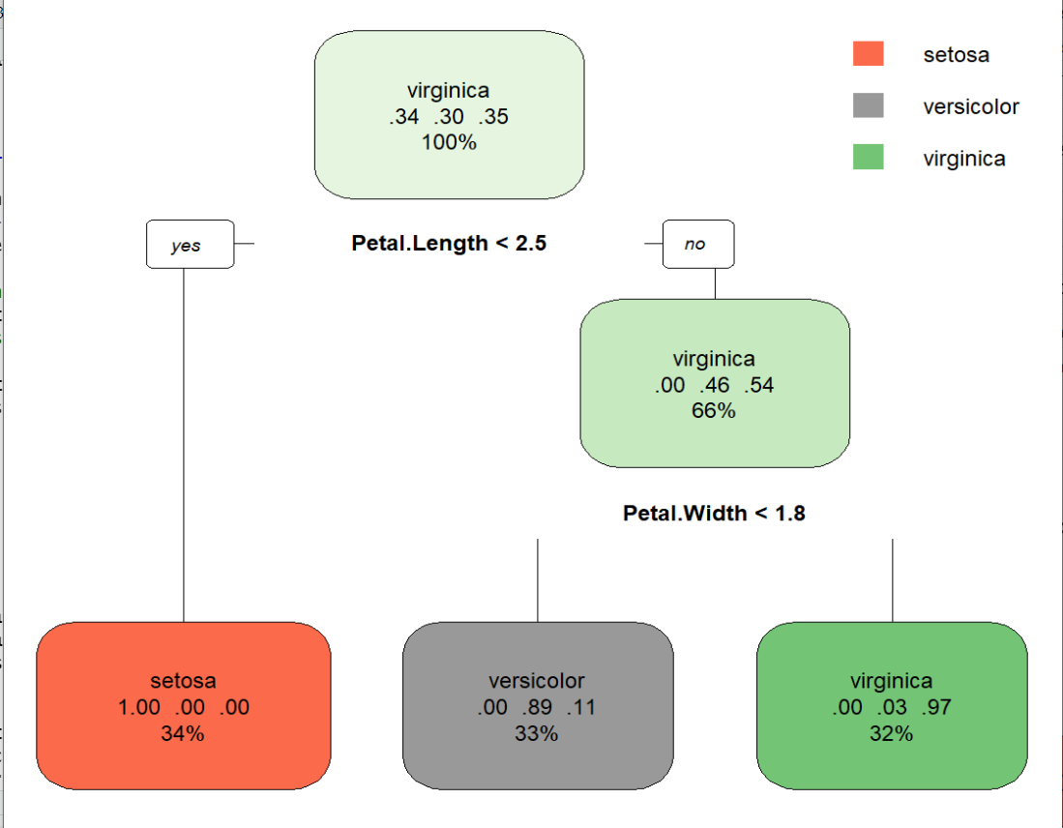

**Observation and Learnings:**

______________________________________________________________________________________________________________________________________________________________________________________________________________________________________________________________________________________________________________________________________________________________________________________________________________________________________________.